LAB

REPORT

# IRE 212 : IoT Architecture and Technologies Sessional

|  |  |
| --- | --- |
| PREPARED BY  Mehrin Farzana  ID: 2101013  Session: 2021-2022  Date: 24/08/2024 | SUPERVISED BY  Suman Saha  Lecturer  Department of IRE, BDU |

|  |  |
| --- | --- |
| logo1 | BANGABANDHU SHEIKH MUJIBUR RAHMAN DIGITAL UNIVERSITY  (BDU) |
|  |  |

**List of Problems**

1.

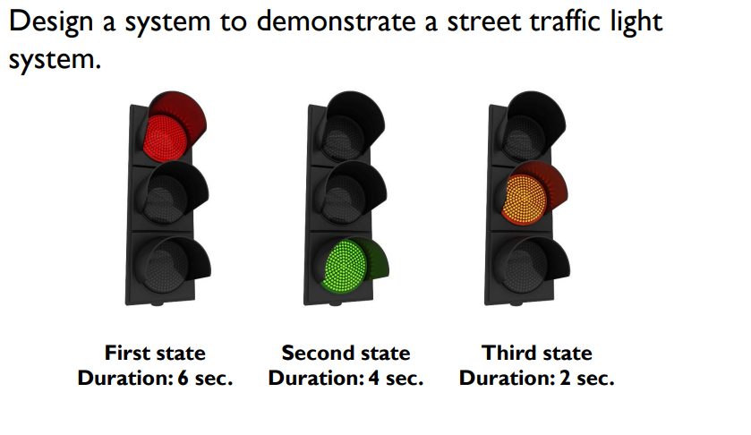

Figure 0: Traffic light system problem statement

**Problem No.:** 01

**Problem Statement:**



Figure 1.1: Traffic light system problem statement

**Code:**

void setup()

{

//2,6,10-red

//3,4,7,8,11,12-yellow

//5,9,13-green

for(int i=2; i<14; i++){

pinMode(i, OUTPUT);

}

Serial.begin(9600);

}

void loop()

{

digitalWrite(2, HIGH);

delay(6000);

digitalWrite(2, LOW);//red

digitalWrite(9, HIGH);

delay(4000);

digitalWrite(9, LOW);//green

digitalWrite(11, HIGH);

digitalWrite(12, HIGH);

delay(2000);

digitalWrite(11, LOW);

digitalWrite(12, LOW);//yellow

}

**Circuit:**

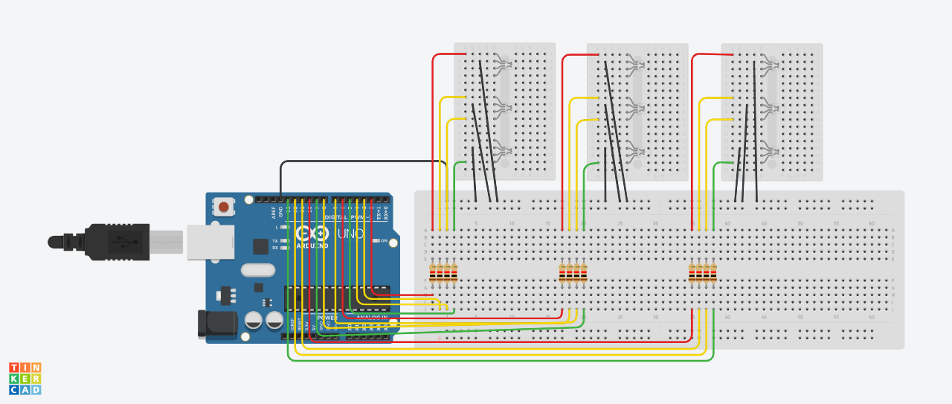

Figure 1.2: Circuit design on a simulator

**Output:**

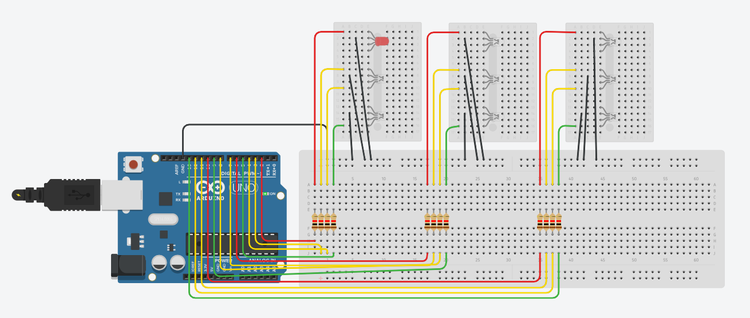

Fig 1.3: Output on simulator.

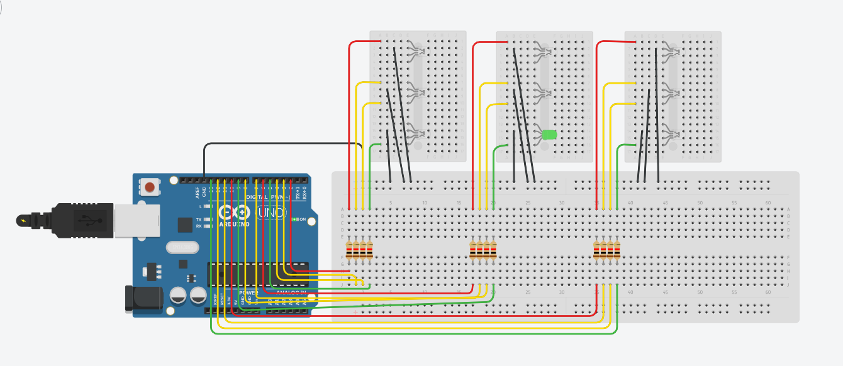

Fig 1.4: Output on simulator.

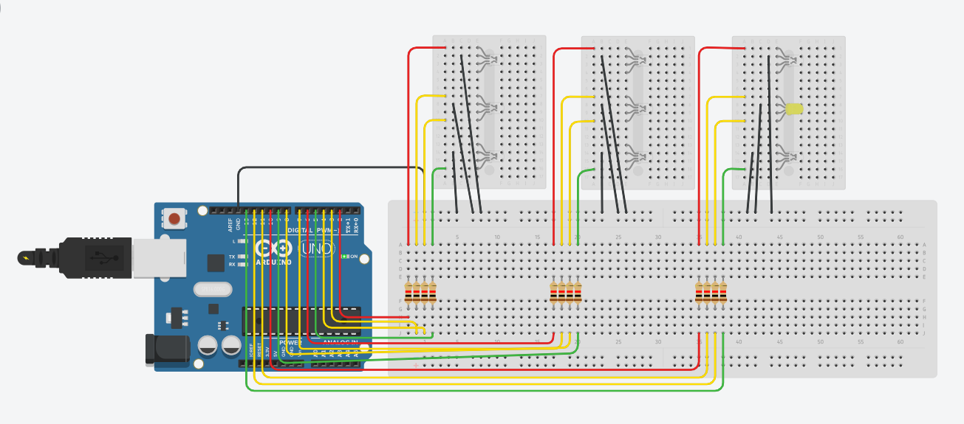

Fig 1.5: Output on simulator.